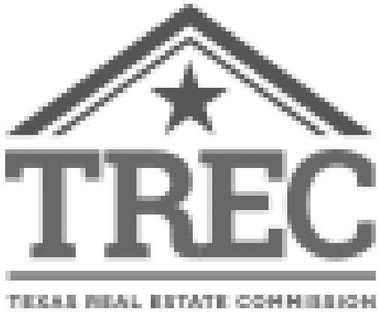
Texas Real Estate Commission

Qualifying Real Estate Course Approval Form (Law of Contracts - 30 hour course)
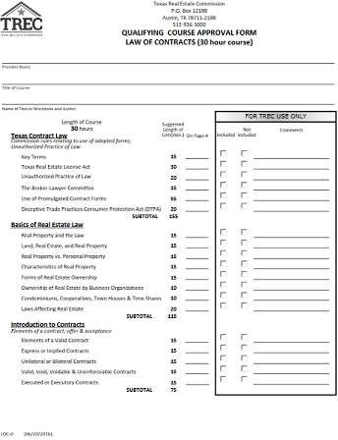

(/sites/default/files/pdf-forms/LOC-0.pdf)

Form Name: Effective Date:
Qualifying Real Estate Course Approval Form (Law of Contracts - 01/17/2017 30 hour course) (Form ID: LOC-0)

Description:
This form is to be submitted with the Qualifying Real Estate Course Application form when requesting approval to offer Law of Contracts.

Related Terms:
Contracts, Forms & Applications, Applications, Education Provider, Qualifying Education (QE) Provider

